**DAY-1**

1. C PROGRAM (Whether comment or not)

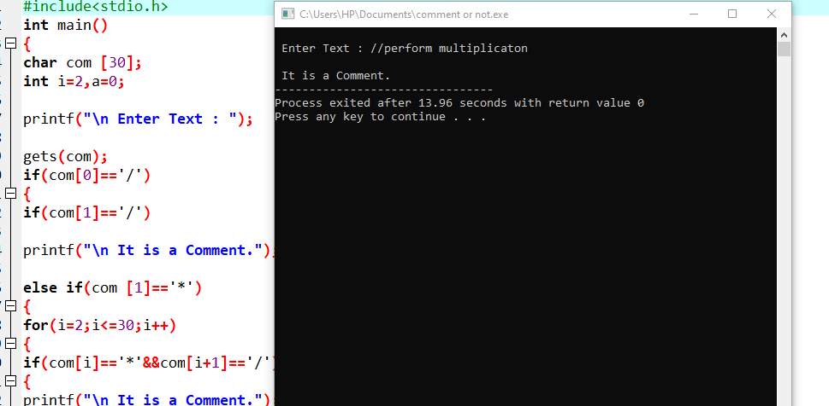

2.LEFT FACTORING:

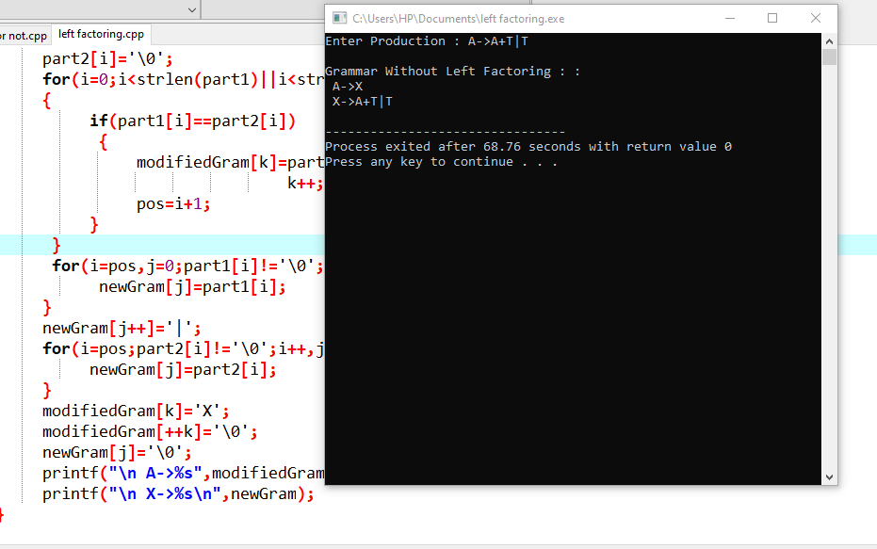

3.LEFT RECURSION

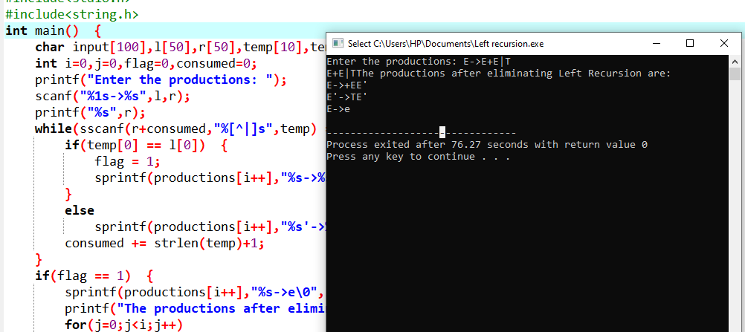

**LEX PROGRAMS:**

1.MOBILE NUMBER

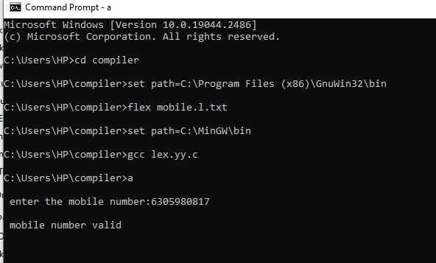

2.EMAIL ID

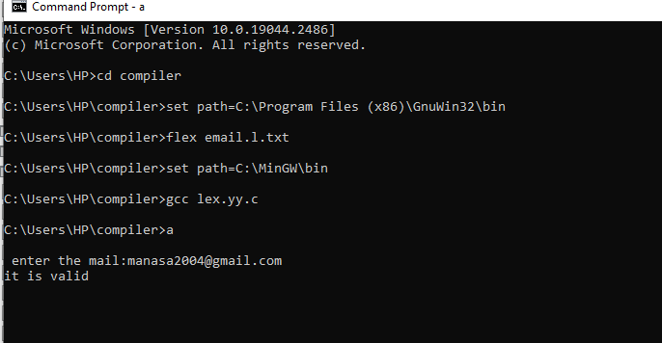

3.DIGIT OR NOT

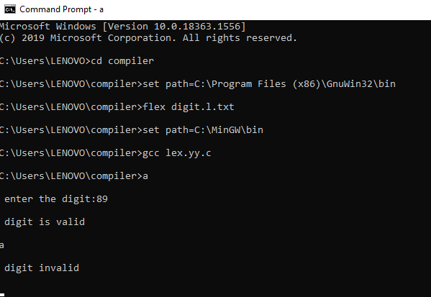

4.VOWELS AND CONSONENTS

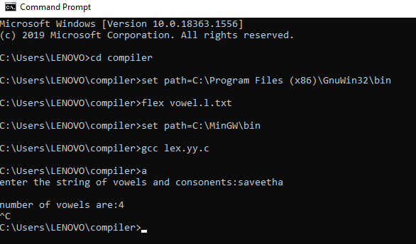

5.URL

